Creating Hard & Soft Links

ln = create link between objects (ln)

- In -s <path_to_existing_file> <path_to_link> (syntax for soft link)

- In <path_to_existing_file> <path_to_link> (direct link to an Inode, creating a duplicate reference This must not traverse directory or file)

Below are examples of soft links listed in a directory

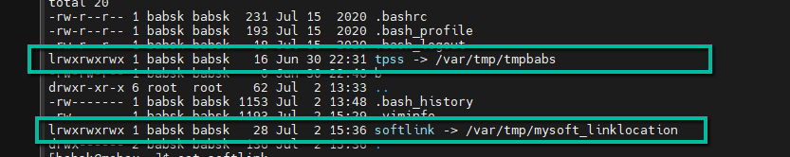

The Inodes numbers of a soft link are different on either side even though they are displaying the same content

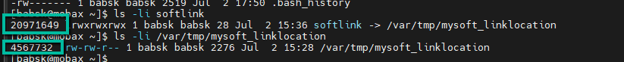

Above is showing the creation of a Hard link with

path of existing file on the left and path to link on the right

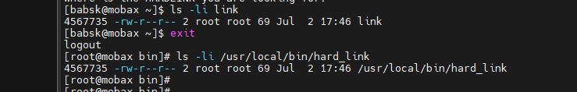

The inode Numbers for a Hard link are the same for both side of the link as they are a duplicate of each other.

